L. Mappin
Head of Pupil Places and Access
Directorate for Children and Young People
PO Box 61
County Hall
Preston
PR1 8RJ

26 November 2012

Dear Lynn,

Statutory Proposal to add a Sixth form to Moor Park Business and Enterprise School

In response to your letter of 21 November 2012 regarding the above proposal;

On behalf of the School and Governing Body I can confirm that the land, premises and capital required to implement the proposals is available.

The alterations to the existing premises to accommodate the proposed sixth form will also benefit provision for 11-16 pupils by providing additional teaching areas and by creating a larger dinning space to address a recognised shortfall.

I can also confirm that following the alterations to the premises, the governing body intends to increase the admission number of 100 towards the indicated number of 108.

The signed proforma is below for your attention.

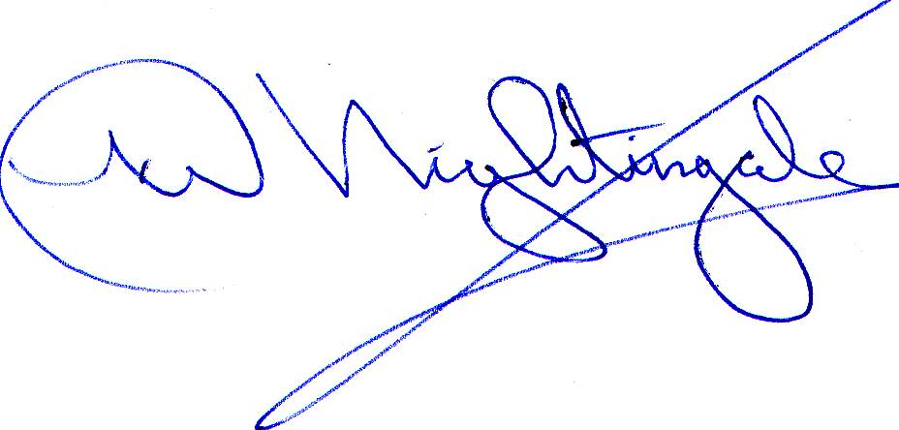
Yours sincerely

Mr K. Nightingale
Chair of Governors

Statutory Proposal to add a sixth form to Moor Park Business and Enterprise School

The Governing Body of Moor Park Business and Enterprise School confirms that it has the necessary capital funds, land and premises available to implement its statutory proposal to add a sixth form to the school with effect from 1 September 2013.

The Governing Body of Moor Park Business and Enterprise School accepts that the Local Authority:

- will expect the current published admission number for Y7 to remain the same (or higher) in future years; and

- the Local Authority will not be obliged to address future shortfalls in capacity for 11 – 16 provision which have arisen as a direct consequence of establishing a sixth form within existing premises at the time that the proposal was made.

Signed Chair of Governors
Moor Park Business and
Enterprise School
Date 26 November 2012

